ASSIGNMENT 10.2

* Create a database named 'custom'.
* Create a table named temperature_data inside custom database with the following fields (delimited by comma - ‘,’ ) : 1. date (mm-dd-yyyy) format 2. zip code 3. temperature

STEP 1:

CREATE A DATABASE NAMED “CUSTOM”

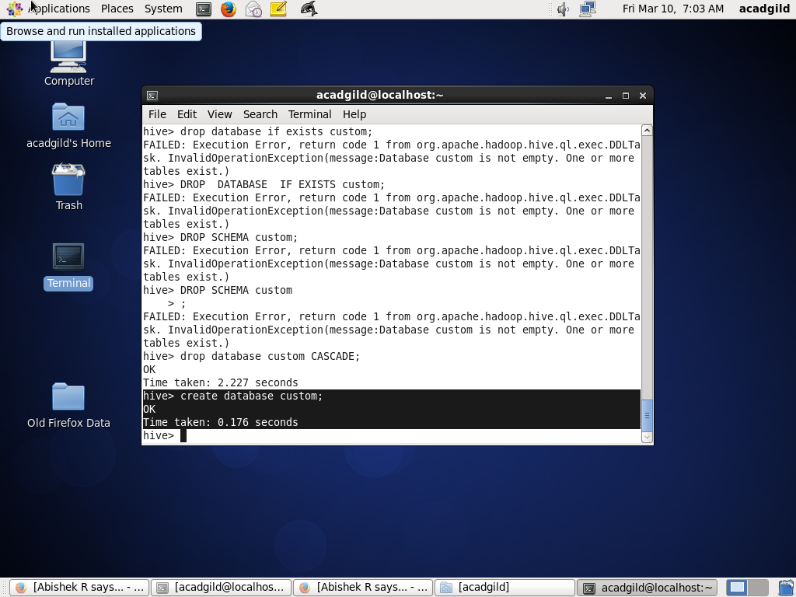

STEP 2:

“use database” command is used to select a specific database for the session on which hive queries would be executed.

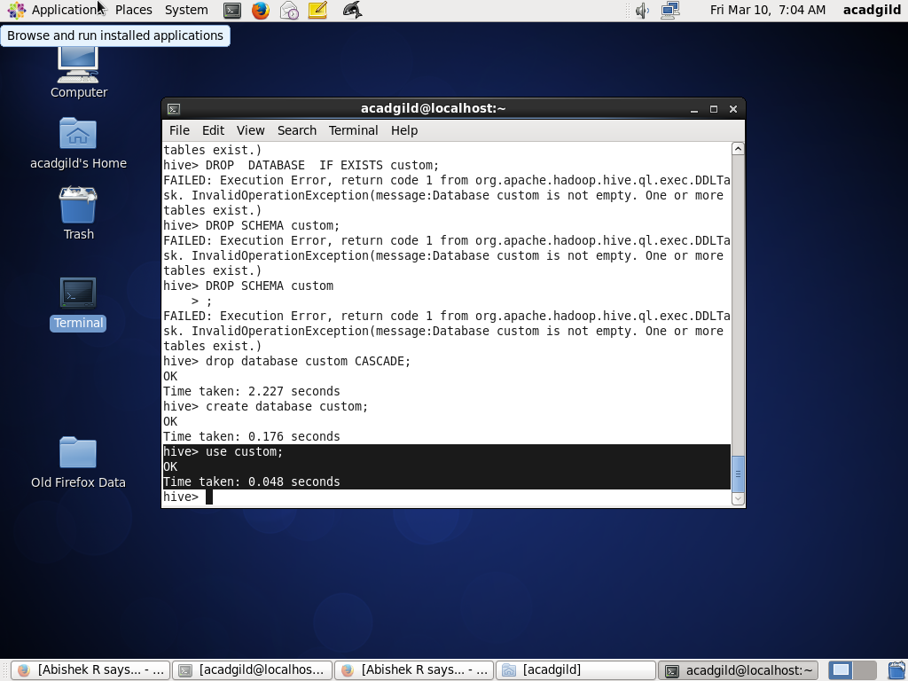

Step 3:

Create table “temperature_data ” inside “ custom “ database

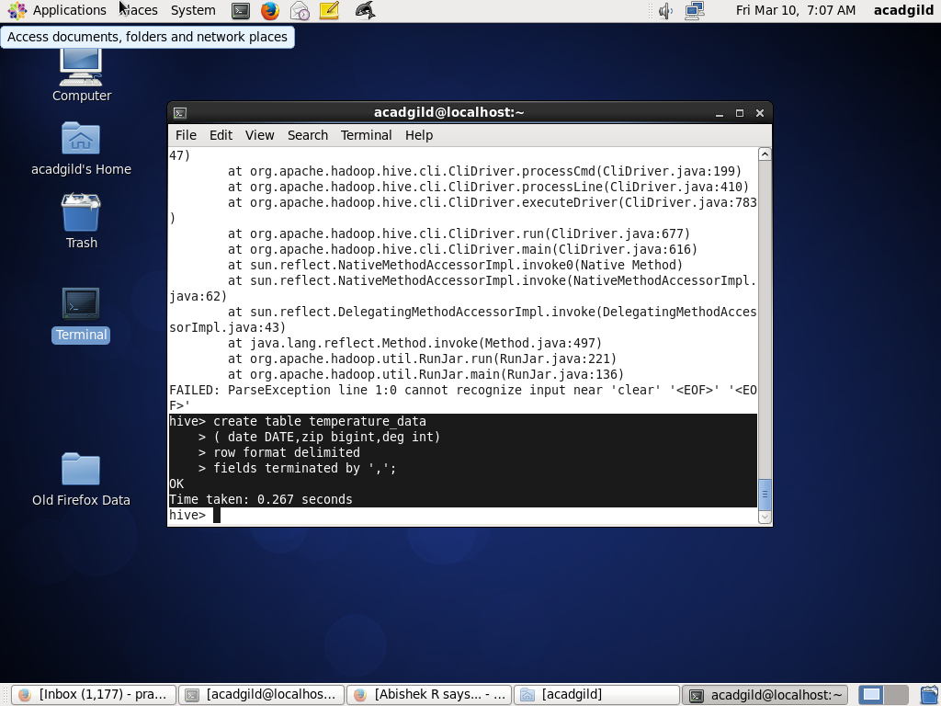

STEP 4:

LOAD THE DATA INTO IT USING ITS PATH

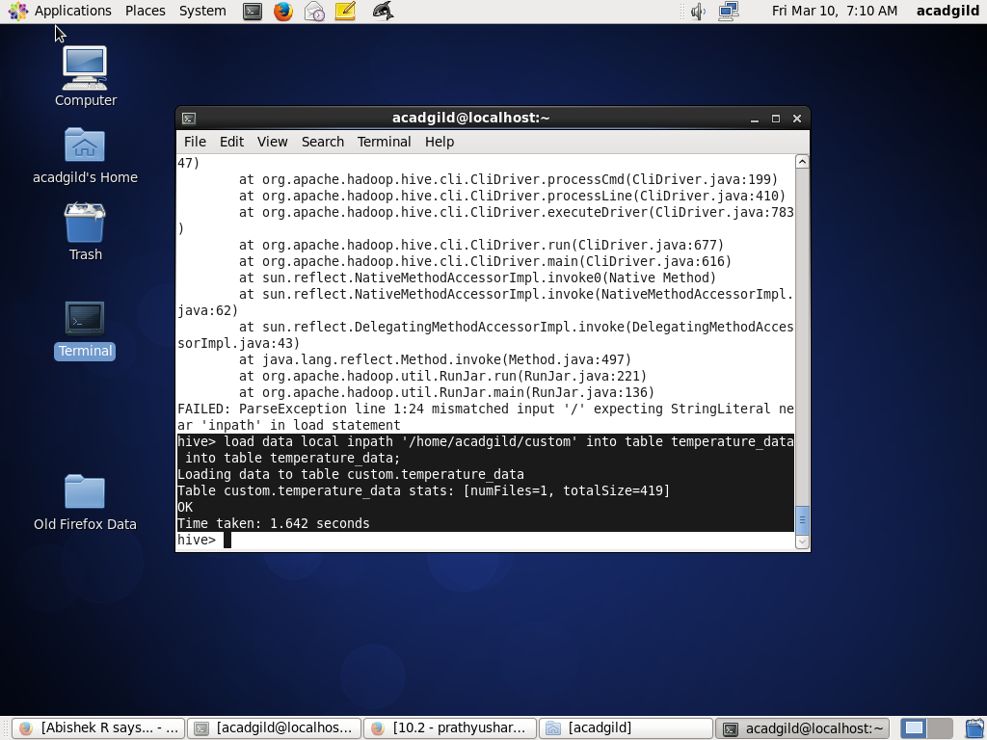

STEP 5: OUTPUT

